

By Abdelrazek Rizk

**Background:**

We are business consulting agency work with business owners on developing a business plan, identifying marketing needs and help in making decisions

**Pharmacies** [**chain stores**](https://en.wikipedia.org/wiki/Chain_store) **in the United States**

The number of community pharmacies increased by **6.3%,** from **63,752** pharmacies in **2007** to **67,753** pharmacies in **2015**

The top **25** pharmacy [chain stores](https://en.wikipedia.org/wiki/Chain_store) represent about **28,000** pharmacy locations in the [U.S.](https://en.wikipedia.org/wiki/United_States) and employ about **46,000** on-staff [pharmacists](https://en.wikipedia.org/wiki/Pharmacist)

**The problem:**

One of our clients is a large drug company and want to buy one of pharmacies [chain stores](https://en.wikipedia.org/wiki/Chain_store) in the United States.

Therefore, we will provided him with statics about pharmacies [chain stores](https://en.wikipedia.org/wiki/Chain_store) .

In addition, help him to make his decisions

**Resource:**

Pharmacies in the United States:

<https://en.wikipedia.org/wiki/Pharmacies_in_the_United_States>

The availability of pharmacies in the United States: **2007–2015**:

<https://journals.plos.org/plosone/article?id=10.1371/journal.pone.0183172#sec012>

Consulting Is More than Giving Advice:

<https://hbr.org/1982/09/consulting-is-more-than-giving-advice>

Examples of Business Consultancy:

<https://www.entrepreneur.com/article/335509>

Image:

<https://www.linuxbusinessexpo.com/fed-up-with-doing-exactly-the-same-boring-factor-be-a-business-consultant/>

**Data:**

1. **Data acquisition**
2. **Wikipedia Data**

The most top five states. [Texas](https://en.wikipedia.org/wiki/Texas), [New York](https://en.wikipedia.org/wiki/New_York_(state)), [Florida](https://en.wikipedia.org/wiki/Florida) ,

[Pennsylvania](https://en.wikipedia.org/wiki/Pennsylvania) and [California](https://en.wikipedia.org/wiki/California) round out for pharmacy chain information in the United States.

<https://en.wikipedia.org/wiki/Pharmacies_in_the_United_States>

1. [**Foursquare API**](https://developer.foursquare.com/)

I queried [Foursquare API](https://developer.foursquare.com/) in order find venues that are most popular in each Pharmacies in the United States

Pharmacy rate, latitude and longitude of each pharmacy

In order to determine which pharmacy chain is the best for our clients.

1. **Csv file:**

Top U.S. pharmacies ranked by prescription drugs market share in **2019**:

<https://www.statista.com/statistics/734171/pharmacies-ranked-by-rx-market-share-in-us/>

Pharmacy and drug store sales in the United States from **1992** to **2018** (in billion U.S. dollars):

<https://www.statista.com/statistics/197635/annual-pharmacies-and-drug-store-sales-in-the-us-since-1992/>

1. **Data cleaning:**

Data downloaded or scraped from multiple sources were combined (Pharmacy_Chains, Pharmacy_share)

Into one table (Pharmacy Chains share)

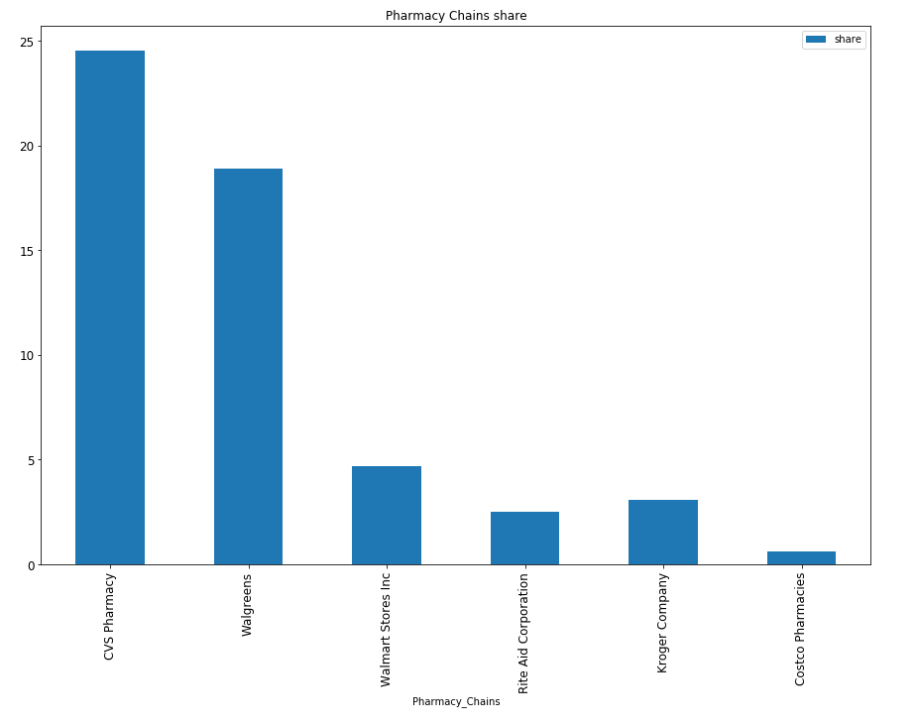

**3. Exploratory Data Analysis:**

Creating a bar chart “Pharmacy Performance and Productivity”

To Show us if there is a relation between the number of stores to Pharmacy_Chains and the number of employees

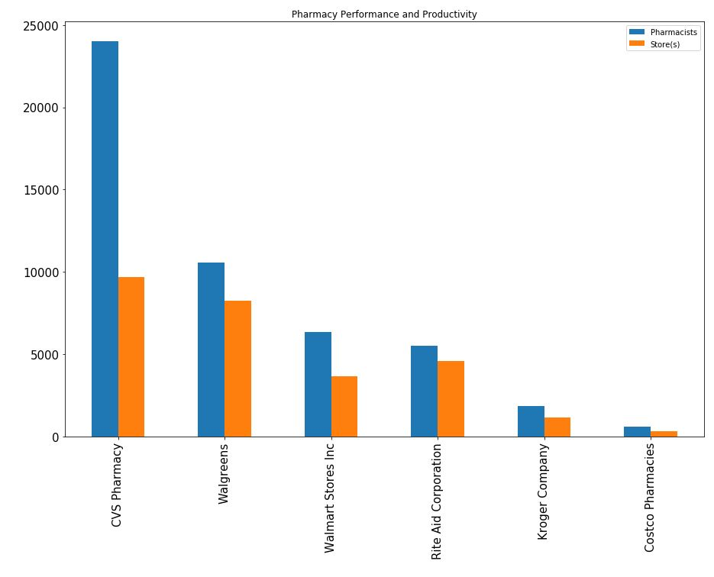

As we see **CVS Pharmacy** their about **~2.4** employees for each store

But if we look to the second-ranked **Walgreens** their about **~1.2** employees for each store

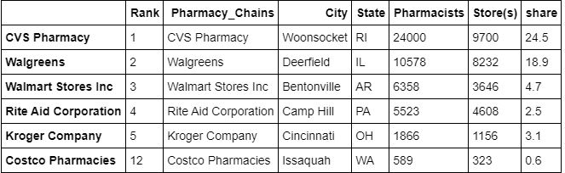

**4. Foursquare Places API Analysis:**

Generate map centered on the Capital of each state to show how pharmacy chain distributions in it

|  |  |  |
| --- | --- | --- |
|  | U.S. state | Capital |
|  | New York, NY | Albany |
|  | Florida, FL | Tallahassee |
|  | Illinois ,IL | Springfield |
|  | Pennsylvania, PA | Harrisburg |
|  | Arkansas, AR | Arkansas |
|  | Ohio, OH | Columbus |
|  | California, CA | Sacramento |
|  | Rhode Island | Providence |
|  | Texas, TX | Austin |

|  |  |
| --- | --- |
| New York, NY | Florida, FL |
|  |  |
| Pharmacy distributed normally North the state Capital City | Pharmacy distributed normally around the state Capital City |
| Illinois ,IL | Pennsylvania, PA |
|  |  |
| Pharmacy distributed The outskirts the state of Capital City | Pharmacy distributed normally South the state Capital City |
| Arkansas, AR | Ohio, OH |
|  |  |
| Pharmacy distributed The outskirts the state of Capital City  Notice: Arkansas, Sacramento and Austin almost the same | Pharmacy distributed normally around the state Capital City |
| California, CA | Rhode Island |
|  |  |
| Pharmacy distributed The outskirts the state of Capital City  Notice: Arkansas, Sacramento and Austin almost the same | Pharmacy distributed normally around the state Capital City |
| Texas, TX |
| Pharmacy distributed The outskirts the state of Capital City  Notice: Arkansas, Sacramento and Austin almost the same |
|  |

**5. Conclusions:**

In that case for given recommendation to our client about

The best choice to make an offer to a pharmacy chain

We use data visualization, data mining, and Geo Capital maps

To give the best solution

We found that

**CVS Pharmacy** chain had employee **24,000** Pharmacists to run **9,700** Store(s) about **~2.4** Pharmacists/store

And has 24.5% market drug sales share about 68.6 billion U.S. dollars in 2018

In the other side **Walgreens Pharmacy** chain had employee **10,578** Pharmacists to run **8,232** Store(s) about **~1.2** Pharmacists/store

And has **18.9%** market drug sales share about **$54 billion** U.S. dollars in **2018**

And we search about additional information about market value

<https://www.gobankingrates.com/money/business/how-much-is-walgreens-worth/>

<https://www.gobankingrates.com/money/business/how-much-is-cvs-worth/>

**CVS Pharmacy** chain Net Worth **$152.2 billion** U.S. dollars

**Walgreens’ Pharmacy** chain Net Worth **$105.6 billion** U.S. dollars in **2018**

**6. Feedback and Recommendations:**

We will give our client to make his offer to **Walgreens Pharmacy** chain as it is less than **CVS Pharmacy** in Net Worth

By **~$50 billion** U.S. dollars

And our client yes he will run **1,468** stores less than **CVS Pharmacy** but he will saving wages for **13,422**‬ Pharmacists